

STAREHE GIRLS’ 2025 PREDICTION
POSSIBLE KCSE EXAM
232/3
PHYSICS
PAPER 3 (PRACTICAL)
TIME: 2½ HOURS

NAME……………………………………………………………………………………….
SCHOOL……………………………………………… SIGN………………………..
INDEX NO……………………………………………. ADM NO……………………

(Kenya Certificate of Secondary Education)

INSTRUCTIONS TO CANDIDATES:-
- Write your name and Adm number and class in the spaces provided above.
- Answer all the questions in the spaces provided in the question paper
- You are supposed to spend the first 15 minutes of 2 ½ hours reading the whole paper carefully before commencing your work.
- Marks are given for a clear record of the observations actually made, their suitability, accuracy and the use of them
- Record your observations as soon as you make them.
- Mathematical tables, slide rules and silent non-programmable electronic calculators may be used.
- Take g = 10ms⁻²
For Examiners’ Use Only:
QUESTION | MAXIMUM SCORE | CANDIDATE SCORE
1 | 20
2 | 20
TOTAL SCORE | 40

QUESTION 1
1 You are provided with the following.
- A new size D dry cell 1.5V in a cell holder
- A voltmeter (Range 0 – 2.5V or 0 – 3.0V)
- An ammeter (Range 0 – 1.0A)
- A Constantine wire, W, mounted on a millimeter scale on a wooden plank
- 7 connecting wires with at least one with a crocodile clip at one end
- A micrometer screw gauge (to be shared)
- A switch
Proceed as follows:
(a)( i) Measure the thickness, t, in meters of the wire, W,
t = __________________________________ (1mark)
(ii) Connect the circuit as shown in the diagram below.
NB: Ensure the circuit is complete before commencing the experiment. The switch K should control both circuits.
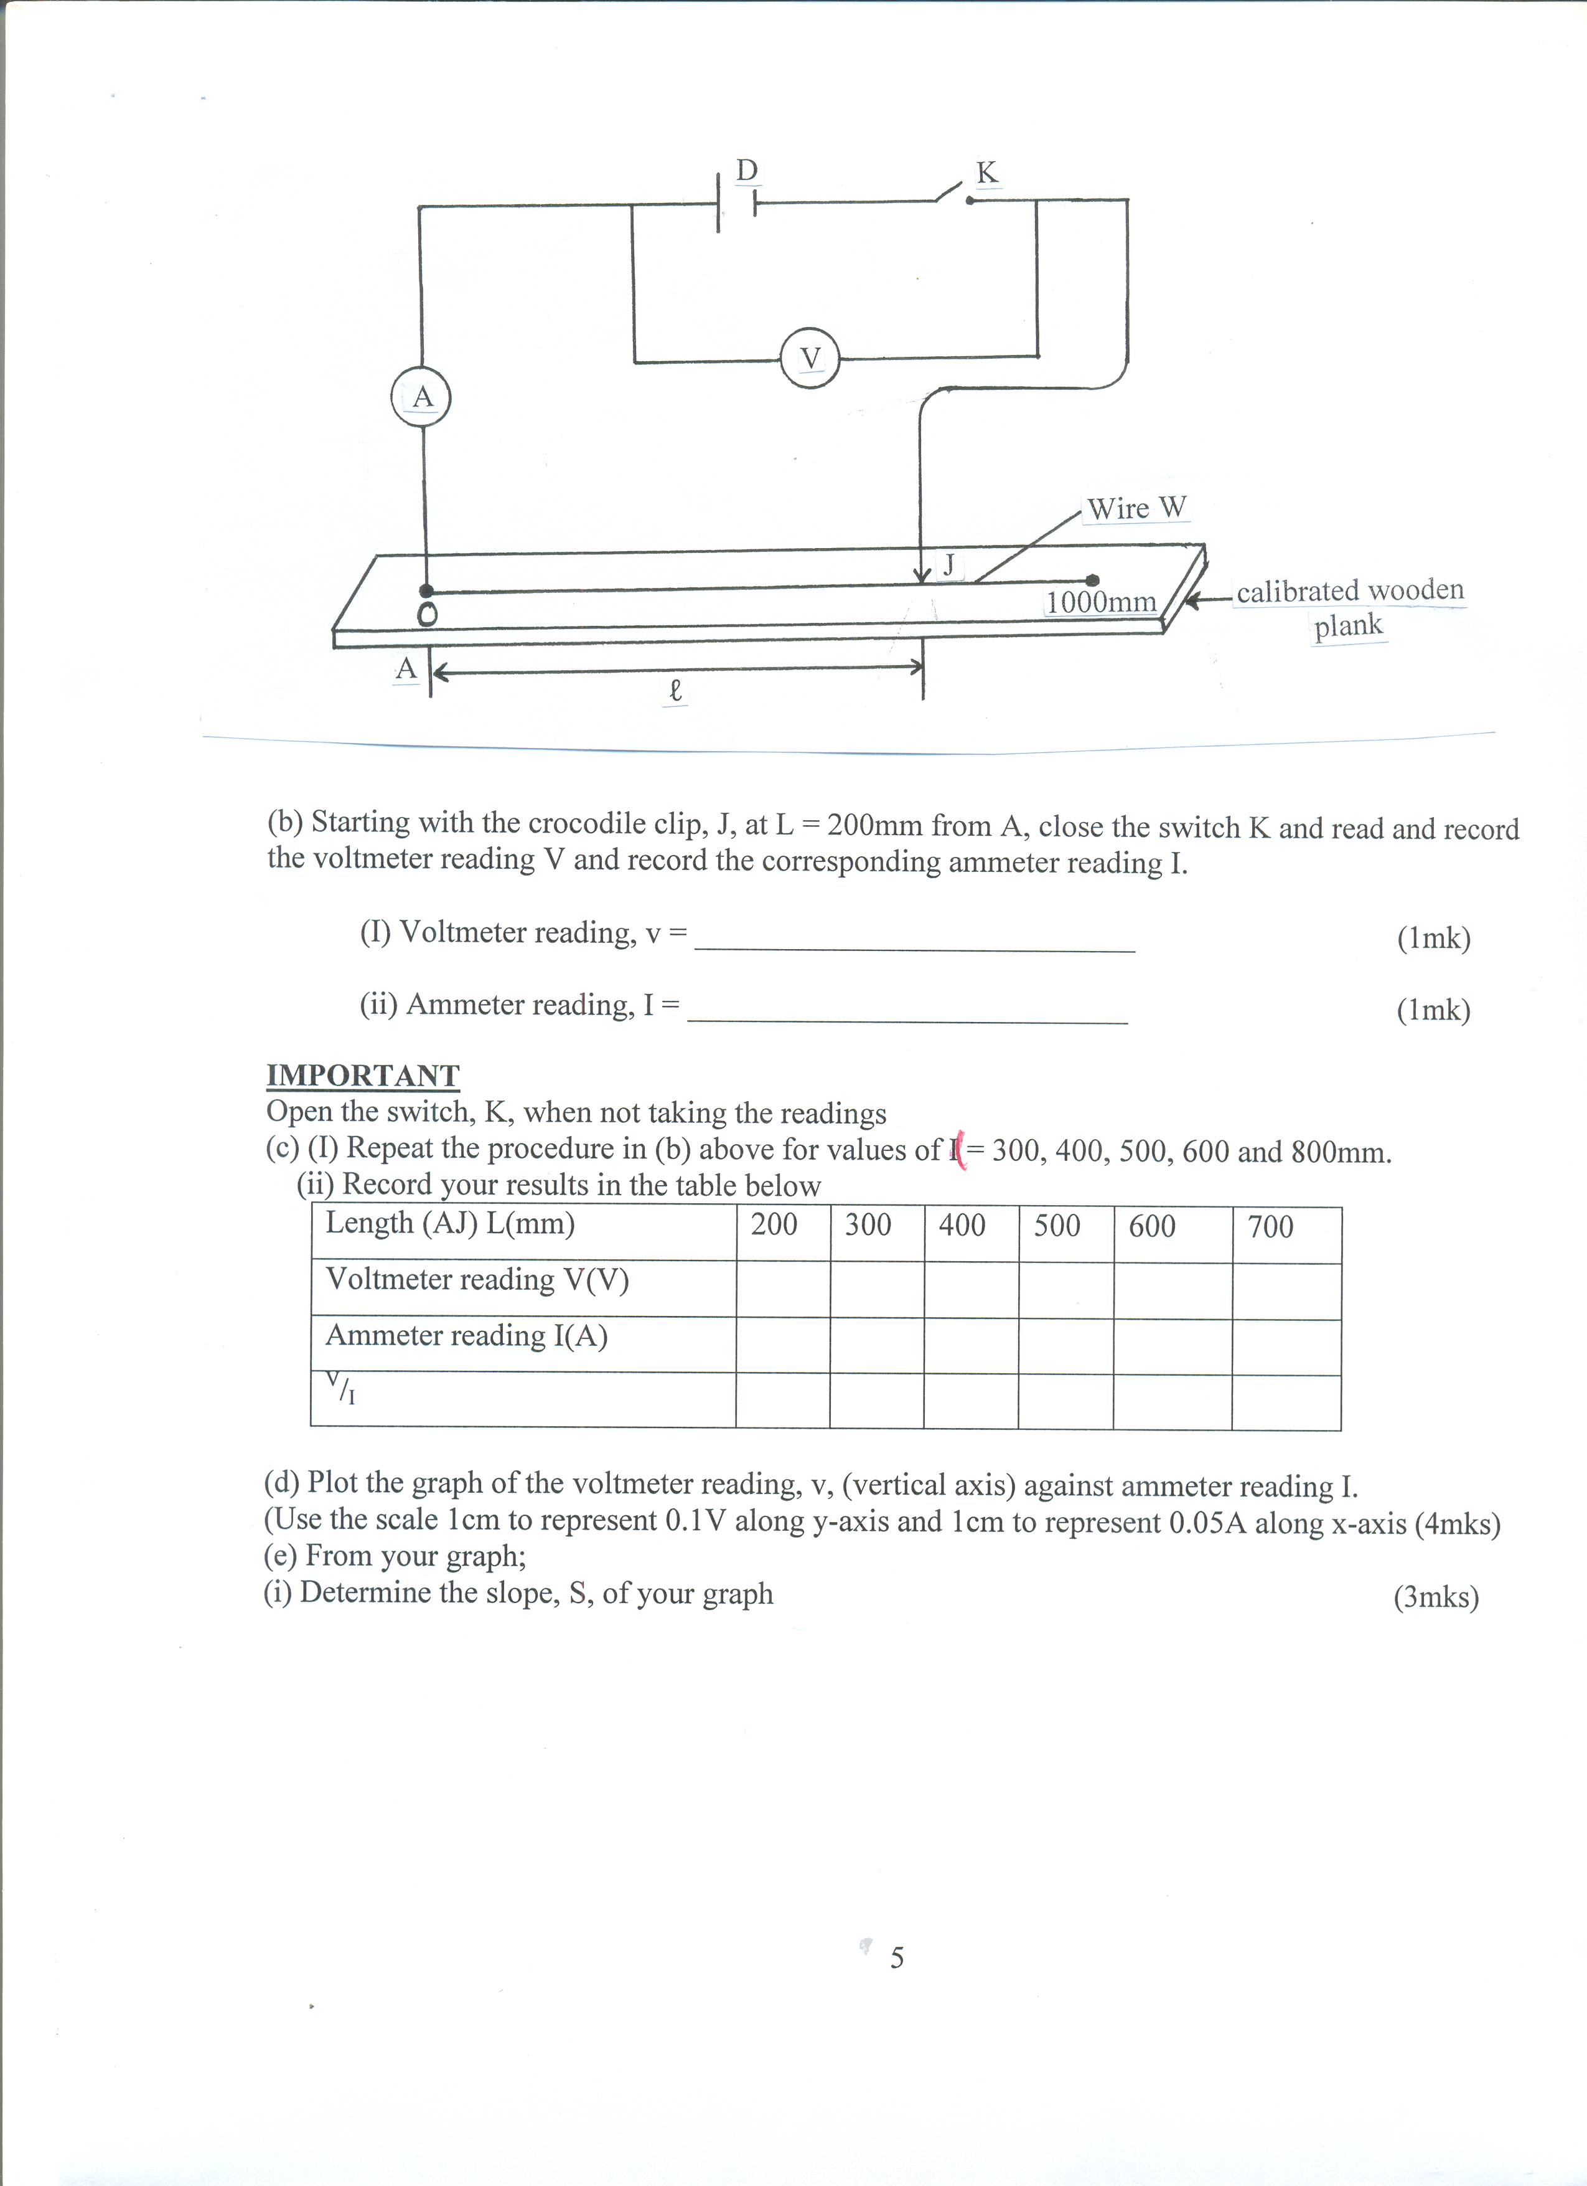
(b) Starting with the crocodile clip, J, at L = 200mm from A, close the switch K and record the voltmeter reading V and the corresponding ammeter reading I.
(i) Voltmeter reading, V = ____________________________ (1mark)

(ii) Ammeter reading, I = ____________________________ (1mark)

NOTE
Open the switch, K, when not taking the readings
(c) (i) Repeat the procedure in (b) above for values of (L= 300, 400, 500, 600 and 800mm.
(ii) Record your results in the table below (5 marks)
Length (AJ) L(mm) | 200 | 300 | 400 | 500 | 600 | 700
Voltmeter reading V(V)
Ammeter reading, I(A)
^{V}/_{I}
(d) Plot a graph of the voltmeter reading, V/I, (vertical axis) against Length L (m). (5marks)

(e) From your graph;
(i) Determine the slope, S, (3marks)

(g) Now connect the voltmeter across the wire, W, to enable you obtain a potential drop across any part of length, AJ, of the wire, W
(i) Using the length, AJ, = L = 550mm, close the switch and then read the voltmeter and corresponding ammeter readings.
Voltmeter reading, V = _____________________________V (1 mark)
Ammeter reading, I = ______________________________ A (1 Mark)

(j) Calculate the value of P from
P=0.785 Vt ²
I L

Where L, V, t and I are quantities obtained in their SI units. (2marks)

QUESTION 2 PART A
You are provided with the following
- Rectangular glass block
- Five optical pins
- Half meter Rule
- Soft board
- Two sheets of Plain papers
- Plane mirror
- Cello tape
- Vernier calipers (to be shared)
- Four Thumb tacks or office pins
(e) Set up the apparatus as shown in figure below
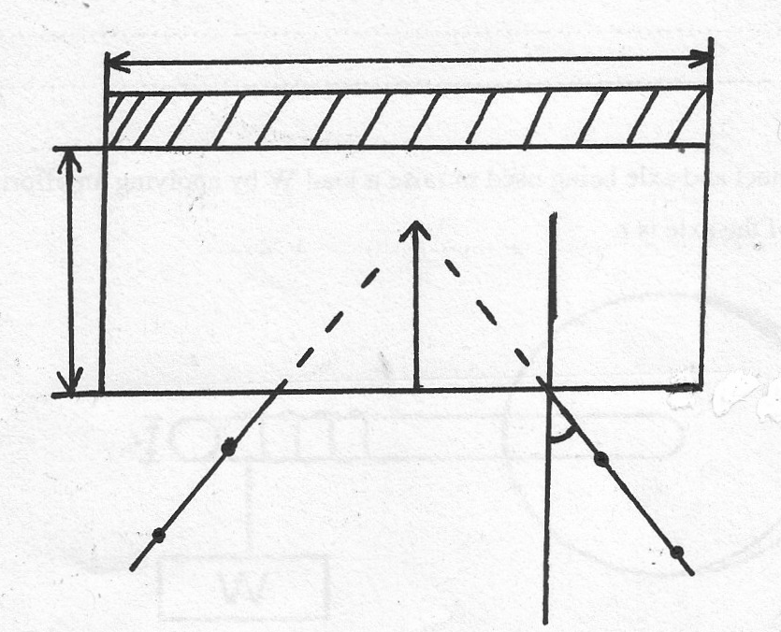
Plane mirror
Glass block
N
K
Y
P₃
P₄
Eye
b
P₂
P₁
i
L

Proceed as follows
a)(i) Using the vernier calipers provided, measure and record the breadth b of the glass block
b=__________________________cm (1 mark)
(ii) Trace the outline of the glass block on the plain sheet of paper (mounted on the soft board using office pins or thumb tacks). Using cello tape, fix the mirror on one side along the length of the glass block.
(iii) Draw the normal NK on the plane paper along the outline as shown in the diagram and measure angle i=20º from the normal
(iv) Draw the line representing the incident ray and fix pins P1 and P2 as shown in the figure
(v) By observing the images of the pins P1 and P2, fix P3 and P4 such that they appear to be in a straight line with the images of P1 and P2 as seen in the glass block .
(vi) Join the points P3 and P4 and extend them to intersect line P1 P2 produced. Measure the perpendicular distance Y
(vii) Repeat steps (iii to vi) for different values of i given and record your values in the table below 2mks
iº | 20 | 25 | 30 | 35
Y(cm)
(viii) Determine the average of the values of Y (2 marks)

(ix) Determine the values of constant k given that (2marks)

b) Measure the length, l, of the glass block using a half meter rule
l = ...................................................... cm (1 mark)
c) Place the glass block on the second plain sheet of paper (mounted on the soft board using office pins or thumb tacks) and trace its outline.
d) Fix a pin P₁ firmly at the middle of one end of the glass block as shown in figure below.

e)With your eye at the opposite end of the block, place pins P₂ and P₃ so that they are in line with the image I of pin P₁ as shown in the figure above. Similarly locate the image I using pins P₄ and P₅.
f) Remove the glass block and produce P₃P₂ and P₅P₄ to their point of interaction.
g) (i) Measure the distance, x, as shown in figure above using a half meter rule
x = ..................................................cm (1 mark)

(ii) Determine the constant q given that
q = l / x (2 marks)

iii) how does q compare with k in question a part ( ix) above (1/2 mark)

(iv) What does constant k and q represent? (1/2 mark)

QUESTION 2 PART B
You are provided with the following:
  - a boiling tube
  - a measuring cylinders
  - a half metre rule
  - water in a container
  - a stand complete with boss and clamp
  - vernier callipers (may be shared)
Proceed as follows:
a) Using the vernier callipers measure the internal diameter, d, of the boiling tube.
(i) d = ........................................................ cm. (1 mark)
(ii) Calculate the cross-sectional A area of the boiling tube (2mks)

b) i) Clamp the boiling tube vertically as shown in the figure below.

ii) Using the measuring cylinder pour 15cm³ of water into the boiling tube. Measure and record in the table 1 the height h, of water in the boiling tube.
iii) Repeat the procedure in b(ii) for other volumes of water, V, shown in the table.
Volume, V, of water (cm³) | Height, h, of water (cm) | Ah
15
20
25
30
(3 marks)
iv) Given that the volume of the liquid is V and height of the liquid is h, write an expression relating the volume, the height, and the area A of the boiling tube as indicated by the values in the table above (2 marks)

